**SETTING UP APPLICATION ENVIRONMENT CREATE FLASKPROJECT**

# Six Steps have been followed to create Flask Project.

TheStepsthatwehavefollowedhavebeendescribed below

**Step 1.** Install Python latest version from python.org

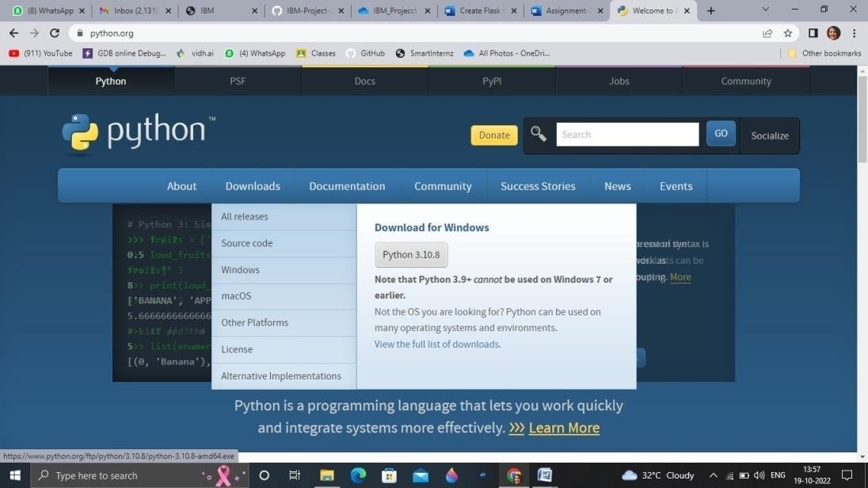

**Step 2**. Download Anaconda from https://[www.anaconda.com/](http://www.anaconda.com/)and install it byrunning the .exe file



**Step 3**.Install Flask using command pip install flask

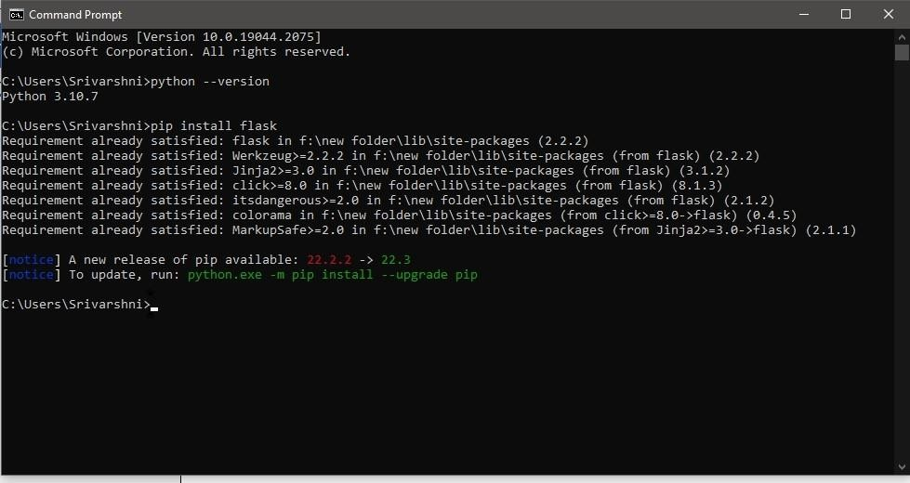

**Step4**.OpenanewPythonfileandstartcoding from flaskimport

Flask app = Flask( name ) @app.route('/')

def hello():

return“HelloWorld” if name== 'main

': app.run(debug=True)

**Step 5**. Run the Python file using command pythonfilename.py

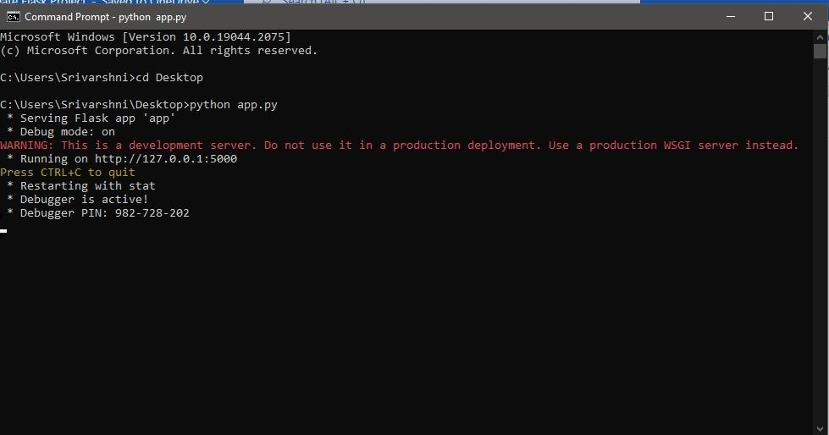

**Step 6**: Open the Ip in browser

